# Hardware Service Catalogue Management

Title: Hardware service catalog

# Abstract

This project is a web application to provide employees utilize computational hardware devices for temporary purposes within the organization. Employees can request for any available hardware device specified in the Catalogue and return it back after a specific duration. Admin or Service Desk members of the organization will list all the available hardware device in the catalogue page where they will have rights of adding a device, removing it or update based on the resources from the organization inventory. [CRUD operation]. Employees can register themselves and the password will be generated via email [advance functionality]. There will be a logic written to calculate the duration to submit back the hardware device within a particular time. Dashboard to display the hardware used and available.

Employees will have a limited view of the application and Admin or Service Desk users will have privileged role to operate many other functionality

# Methodology:

Front end – HTML , CSS , JavaScript ( Bootstrap if needed)

Backend – Python Django framework using SQL for database

EC2 instance, Amazon s3 bucket , cloud watch , load balancers will be used along with CI / CD pipelines as per the need of the application

S3 Bucket , SnS for notification and sqs

## **REQUIREMENT**

Project reference from **E Commerce Project Using Python Django & Library**

**TITLE: IT Hardware Service Catalogue**

**Description ( About) :**

**Welcome to Company Portal.**

**Using the IT Hardware Service Catalogue Page employee can book and use hardware devices for temporary period.This service is majorly to avoid delay in the action by readily providing devices to expedite task.**

**Service to be used only for essential purpose such as client meetings, re-issue of new device, delay in onboarding or customer location visit…..**

**Please raise a request and our IT team will help you with the further information over the call and ticket.**

* **Index page**

login company background

right side 2 login icon (Employee & Admin)

* **Employee Login Page**

**Email authentication password**

Left side panel with options such as

**Dashboard** : will have list of hardware

This page will have widgets with below details

1-> total number of device available

2-> any request created by user

3->Open request

**Catalog page /Products**: each device ( like shopping site) images provided

**Create a Request** : On click of any device in the Catalog Page , employee should be re-directed to form where they can fill the below details and submit for any device required

Welcome to Company ! Please fill the below details for your device

Request Number: Auto Generate Number from 1000 ( +)

Employee name: <input type = text align center>

Contact number: <input type = text align center> 10 digits validation

Email ID: <input type = email align center> email ID validation

Work Location: <input type = text align center>

Desk Number: <input type = text align center>

Device Required: <input type = text align center>

Comments : < input type = text , multi line box >

Attachment icon :

Submit

Submission Page: After submit button form re-directs to thank you page

Message:

**Thank you to submit the request. Your request will processed and you shall receive a call to collect your device from the IT Room ( Located in 3rd floor A Block )**

**You will have to submit the device after 10 working days**, Please re-open a new ticket to extend using the device OR employee needs to open a ticket with “New Device Request” using the another Portal of the company , refere handbook for more details

**Employees are recommended to use the ticket for timely update or any feedback.**

**MY Orders** : View list of all ordered devices and their details

User will be able to click on item example mouse and book (rent ) it for default 5 days (calculate 5 days and show date to return the device )

After 5 days penalty on employee ( Auto generate email on 4th day to submit the device in IT department)

User can download details

MyOrder page should have Action =-Return / Cancel /Penalty

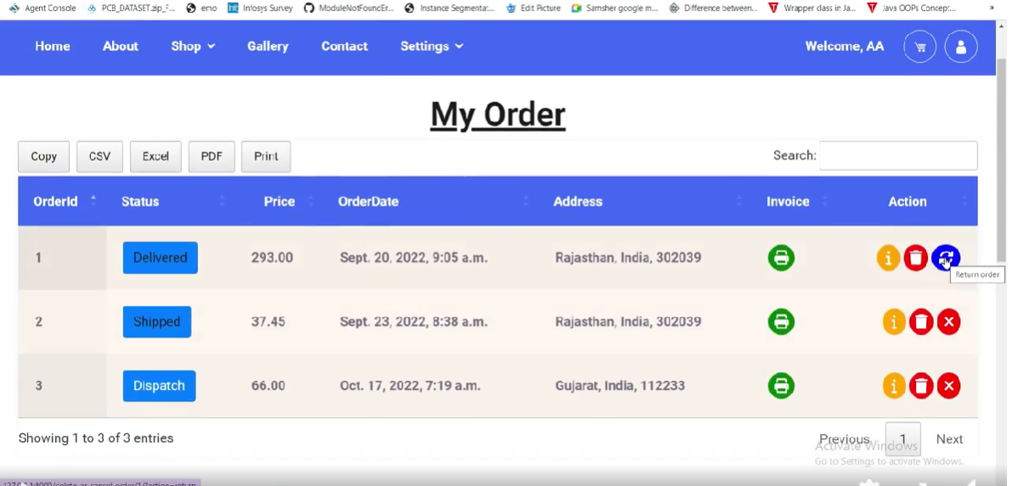

**Profile** : employee user name / phone number / email address/ company code / department/ work location / work desk / Office adderss

Change Password

Logout : Simply exit the web application

* **Admin Login Page**

Left side panel with options such as

Dashboard : will have list of hardware used and ordered items

Catalog page : each device ( like shopping site) images provided

Admin users can ADD / EDIT / DELETE device images and description

Profile : employee user name / phone number / email address/ company code / department/ work location / work desk / Office address

Logout : Simply exit the web application

Website

Reference: E Commerce Project Using Python Django | By PanjwaniSoftwares | Facebook

Images

Reference:

